Task on Load Balancers

- Configure Classic Load balancer.
Objective
To configure an AWS Classic Load Balancer (CLB) and distribute incoming application traffic across multiple EC2 instances. The load balancer improves application availability by distributing requests between healthy instances.
Step-by-Step Process
Step 1: Prepare EC2 Instances
- Log in to the AWS Management Console.
- Navigate to EC2 → Instances.
- Launch or use two EC2 instances in the same VPC.
- Ensure that both instances have the required web server installed, such as Apache HTTP Server.
- Start the web server on both instances.
- Configure the security group to allow HTTP traffic on port 80.
- Create different test pages on the two instances so that the response from each instance can be identified.
Example:
- Instance 1: Welcome to Server 1
- Instance 2: Welcome to Server 2
Step 2: Create the Classic Load Balancer
- Open the EC2 Dashboard.
- Select Load Balancers from the left-side menu.
- Click Create Load Balancer.
- Select Classic Load Balancer.
- Enter a suitable name for the load balancer, for example:
  - My-Classic-Load-Balancer
- Select the appropriate VPC.
- Select the required Availability Zone(s) and subnet(s).
- Configure the listener:
  - Load Balancer Protocol: HTTP
  - Load Balancer Port: 80
  - Instance Protocol: HTTP
  - Instance Port: 80
Step 3: Configure Security Groups
- Select or create a security group for the load balancer.
- Add an inbound rule to allow:
  - Type: HTTP
  - Port: 80
  - Source: 0.0.0.0/0 for a public testing environment.
- Ensure that the EC2 instance security group allows HTTP traffic from the load balancer.
Step 4: Configure Health Check
Configure the CLB health check to monitor the web servers.
Use settings such as:
- Ping Protocol: HTTP
- Ping Port: 80
- Ping Path: /
- Timeout: 5 seconds
- Interval: 30 seconds
- Unhealthy Threshold: 2
- Healthy Threshold: 10
The load balancer uses this health check to determine whether an EC2 instance is healthy enough to receive traffic.
Step 5: Add EC2 Instances
- Select both EC2 instances.
- Add them as registered instances behind the Classic Load Balancer.
- Complete the load balancer creation process.
- Wait until the instances show a healthy status.
Step 6: Verify the Load Balancer
- Open EC2 → Load Balancers.
- Select the newly created Classic Load Balancer.
- Copy the DNS name of the load balancer.
- Open the DNS name in a web browser.
- Verify that the web application is accessible through the load balancer.
- Refresh the page multiple times or test the application to verify that requests can be distributed between the registered EC2 instances.
Step 7: Verify Instance Health
- Open the Classic Load Balancer.
- Go to the Instances or Registered Instances section.
- Verify that the registered EC2 instances show In Service/Healthy status.
- This confirms that the CLB can communicate with the backend instances.
3. Evidence / Screenshots
Include the following screenshots in the documentation:
Screenshot 1 – EC2 Instances
Show the two EC2 instances used as backend servers.
Evidence: Confirms that multiple EC2 instances are available for load balancing.
Screenshot 2 – Classic Load Balancer Configuration
Show the CLB name and basic configuration.
Evidence: Confirms that the Classic Load Balancer was successfully created.
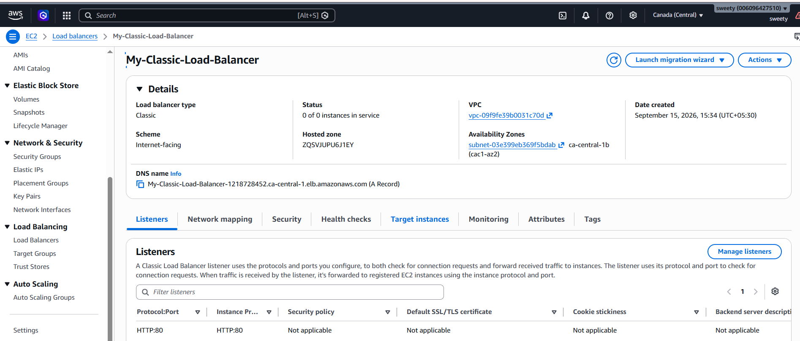
Screenshot 3 – Listener Configuration
Show:
- Load Balancer Protocol: HTTP
- Load Balancer Port: 80
- Instance Protocol: HTTP
- Instance Port: 80
Evidence: Confirms that HTTP traffic is configured on port 80.
Screenshot 4 – Registered Instances
Show both EC2 instances registered with the Classic Load Balancer.
Evidence: Confirms that the backend instances are attached to the CLB.
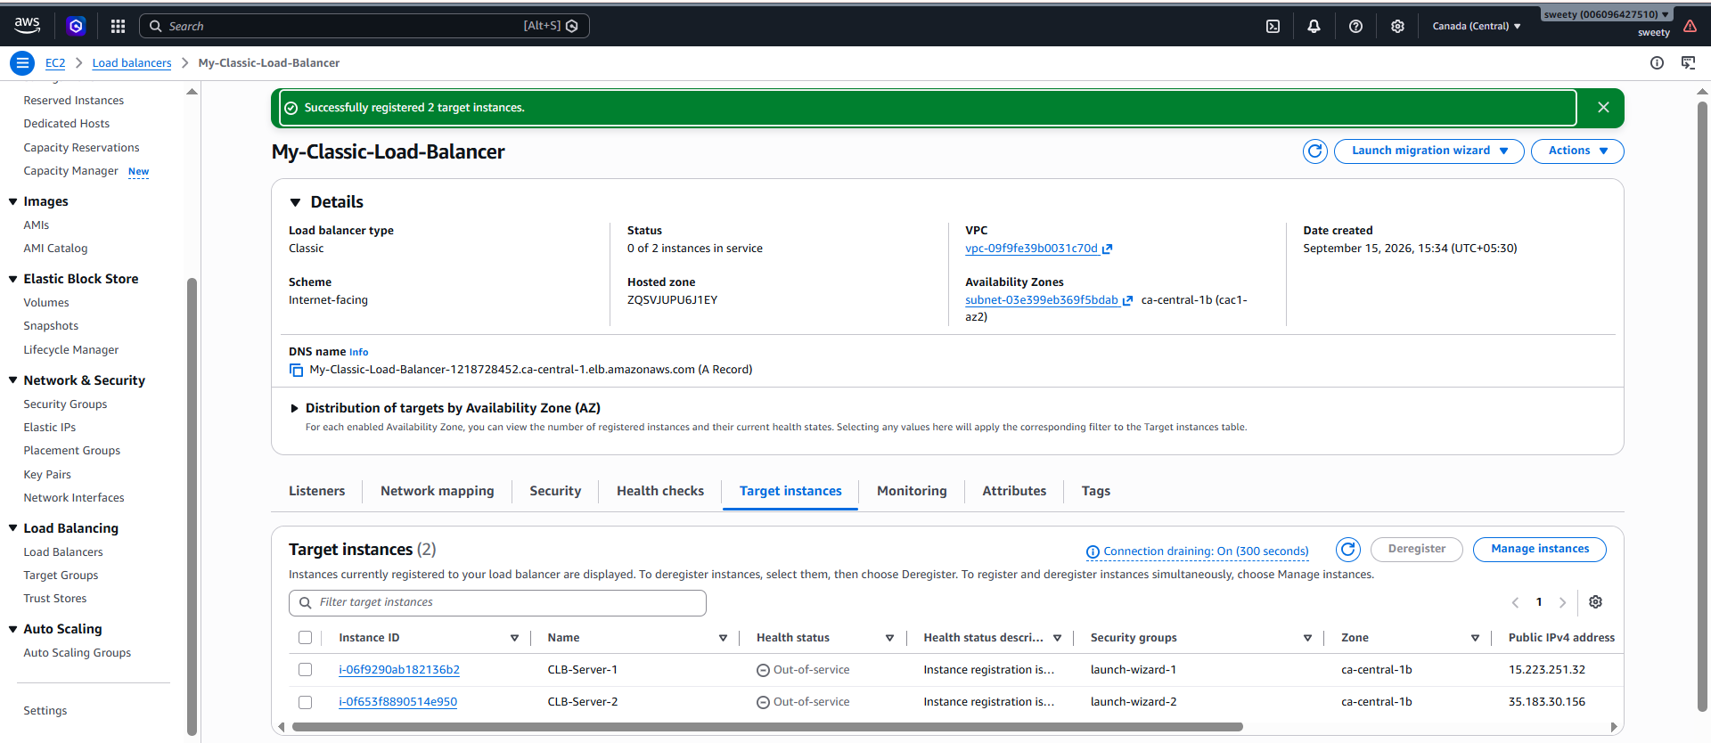
Screenshot 5 – Health Check / Instance Health
Show both instances in Healthy / In Service status.
Evidence: Confirms that the CLB health checks are working successfully.
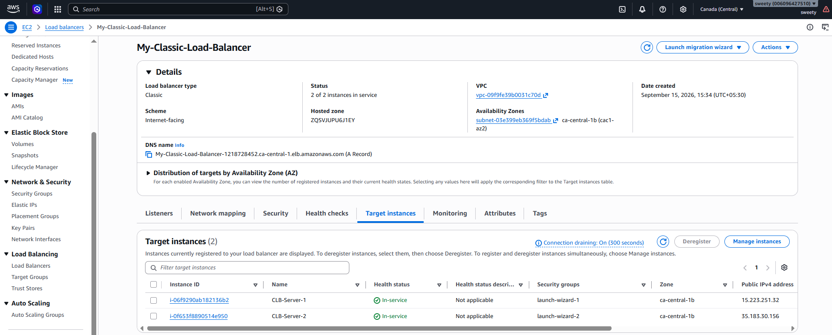
Screenshot 6 – Load Balancer DNS
Show the CLB DNS name and the successful web page response in the browser.
Evidence: Confirms that the application is accessible through the Classic Load Balancer.
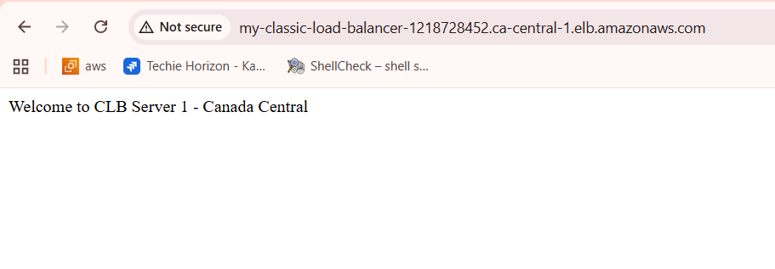
Conclusion
The AWS Classic Load Balancer was successfully configured with multiple EC2 instances. The instances were registered with the load balancer, health checks were configured, and both instances were verified as healthy. The application was successfully accessed through the CLB DNS name, demonstrating that the load balancer can distribute incoming traffic across the backend instances.

- Configure Application Load balancer.
Objective
To configure an AWS Application Load Balancer (ALB) to distribute HTTP traffic across multiple EC2 instances and verify that the application is accessible through the ALB DNS name.

Step-by-Step Process
Step 1: Verify EC2 Instances
We'll use the two existing web servers:
- CLB-Server-1
- CLB-Server-2
Make sure both are:
- Running
- Have Apache/web server running
- Allow HTTP port 80
- Located in the same VPC
Since you already verified that both servers work, you don't need to create new EC2 instances
Step 2: Create a Target Group
Before creating the ALB, create a target group.
Go to:
EC2 → Target Groups → Create target group
Select:
Target type:
Instances
Then configure:
- Target group name: ALB-Target-Group
- Protocol: HTTP
- Port: 80
- IP address type: IPv4
- VPC: Select your existing VPC
vpc-09f9fe39b0031c70d
Health Check
Use:
- Health check protocol: HTTP
- Health check path: /
Leave the other health-check settings at their defaults unless your assignment specifies different values.
Click Next.
Register Targets
Select:
- CLB-Server-1
- CLB-Server-2
Make sure port 80 is selected.
Click:
Include as pending below
Then click:
Create target group

Step 3: Create Application Load Balancer
Go to:
EC2 → Load Balancers → Create Load Balancer
Select:
Application Load Balancer
Click Create.
Basic Configuration
Enter:
Load Balancer name:
My-Application-Load-Balancer
Select:
Scheme:
Internet-facing
IP address type:
IPv4

Step 4: Configure Network Mapping
Select your existing VPC:
vpc-09f9fe39b0031c70d
For Availability Zones, select at least two Availability Zones if available.
For example:
- ca-central-1a
- ca-central-1b
Select the corresponding default/public subnets.
Important
Unlike your CLB configuration, for the ALB I recommend selecting two Availability Zones.
This provides better availability and is also a good demonstration of how ALBs are normally configured.

Step 5: Configure Security Group
Create or select a security group for the ALB.
For example:
ALB-Security-Group
Add this inbound rule:
Type | Protocol | Port | Source
HTTP | TCP | 80 | 0.0.0.0/0
This allows users to access the ALB over HTTP.

Step 6: Configure Listener
Under Listeners and routing, configure:
Setting | Value
Protocol | HTTP
Port | 80
Default action | Forward to ALB-Target-Group
So the traffic flow becomes:
User → ALB : 80 → Target Group → EC2 : 80
Select:
ALB-Target-Group
as the forwarding target.

Step 7: Create the ALB
Review the configuration:
- Name: My-Application-Load-Balancer
- Scheme: Internet-facing
- VPC: Your VPC
- At least two AZs/subnets
- HTTP listener: port 80
- Target group: ALB-Target-Group
- Security group: HTTP 80 allowed
Then click:
Create load balancer
AWS will create the ALB.

3. Verify Target Health
After the ALB is created:
Go to:
EC2 → Target Groups → ALB-Target-Group → Targets
You should eventually see:
Target | Status
CLB-Server-1 | Healthy
CLB-Server-2 | Healthy
It may initially show Initial while AWS performs the health checks.
Wait a few minutes and refresh.

4. Test the Application
Go to:
EC2 → Load Balancers → My-Application-Load-Balancer
Copy the DNS name.
It will look similar to:
My-Application-Load-Balancer-xxxxxxxx.ca-central-1.elb.amazonaws.com
Open:
http://<ALB-DNS-name>
You should see your web page.

5. Evidence / Screenshots
For your Word document, capture these screenshots:
Screenshot 1 – Target Group
Show:
- Target group name
- HTTP protocol
- Port 80
- VPC
Evidence: Confirms that the ALB target group was configured.
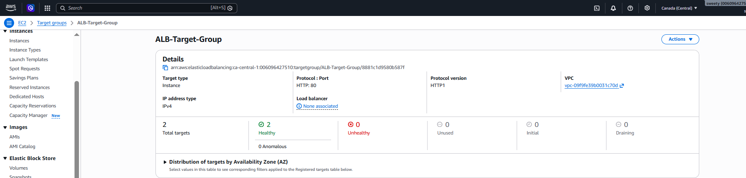
Screenshot 2 – Registered Targets
Show both:
- CLB-Server-1
- CLB-Server-2
with Healthy status.
Evidence: Confirms that both EC2 instances are successfully registered and passing health checks.
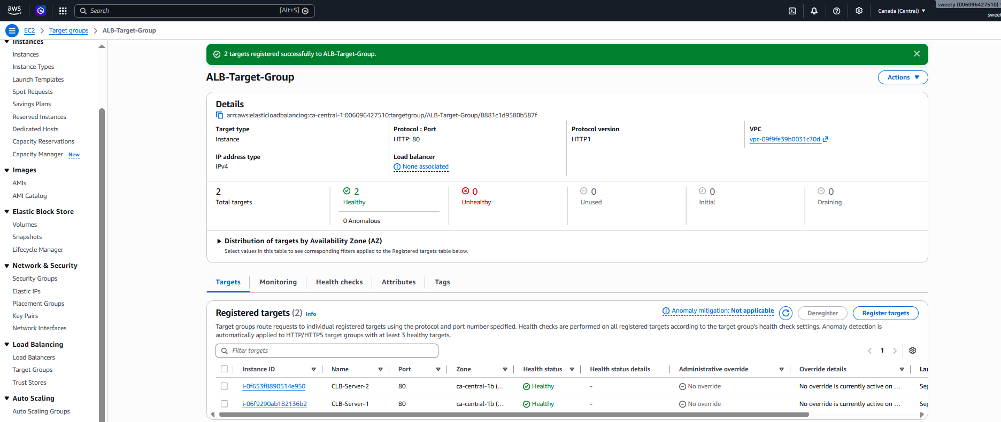
Screenshot 3 – ALB Configuration
Show:
- ALB name
- Application Load Balancer
- Internet-facing
- IPv4
- VPC
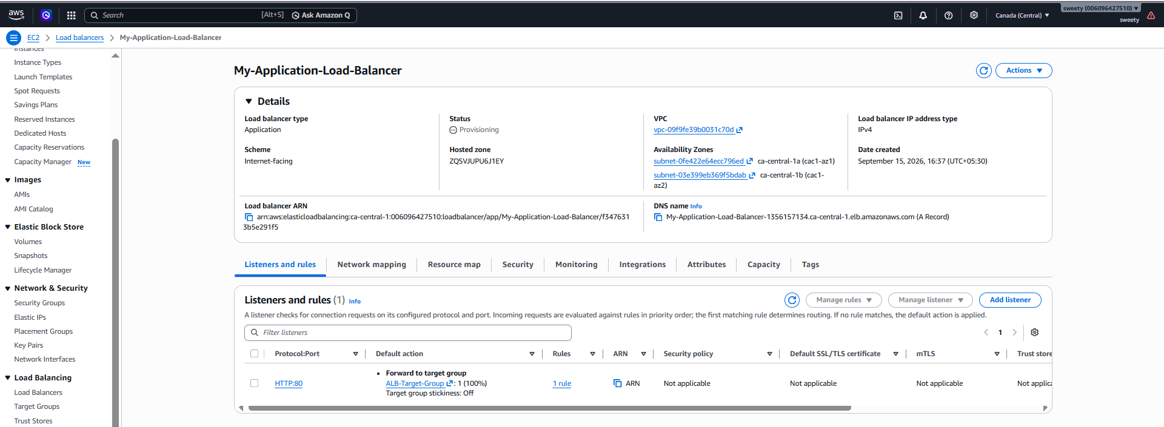
Screenshot 4 – ALB Listener
Show:
HTTP : 80 → Forward to ALB-Target-Group
Screenshot 5 – Availability Zones / Network Mapping
Show the two selected Availability Zones/subnets.
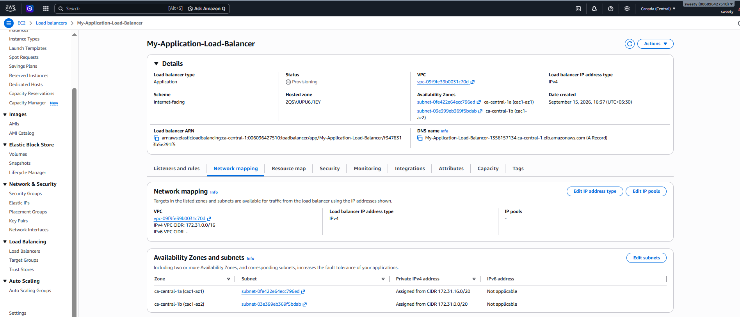
Screenshot 6 – Final Application Test
Show the browser displaying your application through the ALB DNS name.
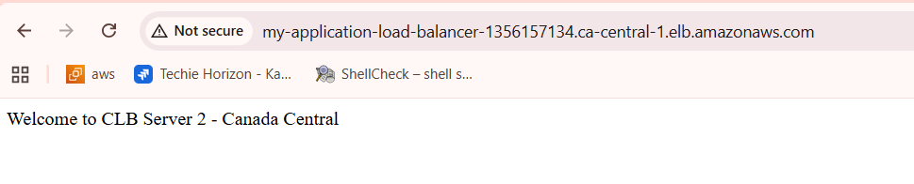
Conclusion
The Application Load Balancer was successfully configured in the AWS Canada (Central) Region. A target group was created and two EC2 instances were registered as targets. Both instances passed the configured health checks, and HTTP traffic was successfully forwarded from the Application Load Balancer to the healthy EC2 instances. The application was verified through the ALB DNS name.

- Configure Network Load balancer.
1. Objective
To configure a Network Load Balancer (NLB) in AWS Canada (Central) to distribute TCP traffic to multiple EC2 instances and understand Layer 4 load balancing using TCP protocol.
2. Step-by-Step Process
Step 1: Create the NLB Target Group
- Open the AWS Management Console.
- Navigate to EC2 → Target Groups.
- Click Create target group.
- Select Target type: Instances.
- Enter the target group name:
NLB-Target-Group
- Configure the target group:
  - Protocol: TCP
  - Port: 80
  - IP address type: IPv4
  - VPC: vpc-09f9fe39b0031c70d
- Configure the health check:
  - Health check protocol: HTTP
  - Health check path: /
- Click Next.
Step 2: Register EC2 Targets
The following EC2 instances were selected as targets:
Instance | Port | Availability Zone
CLB-Server-1 | 80 | ca-central-1b
CLB-Server-2 | 80 | ca-central-1b
Both instances were registered with the NLB-Target-Group.
Step 3: Create the Network Load Balancer
- Navigate to EC2 → Load Balancers.
- Click Create load balancer.
- Select Network Load Balancer.
- The intended configuration was:
  - Name: My-Network-Load-Balancer
  - Scheme: Internet-facing
  - IP address type: IPv4
  - VPC: vpc-09f9fe39b0031c70d
  - Availability Zones: ca-central-1a and ca-central-1b
  - Listener: TCP port 80
  - Target group: NLB-Target-Group
- The configuration was submitted for creation.

3. Evidence / Screenshots
Evidence 1 – NLB Target Group Configuration
Take a screenshot showing:
- NLB-Target-Group
- Target type: Instances
- Protocol: TCP
- Port: 80
- IPv4
- VPC: vpc-09f9fe39b0031c70d
- Health check: HTTP /
Caption:
Figure 1: NLB Target Group Configuration
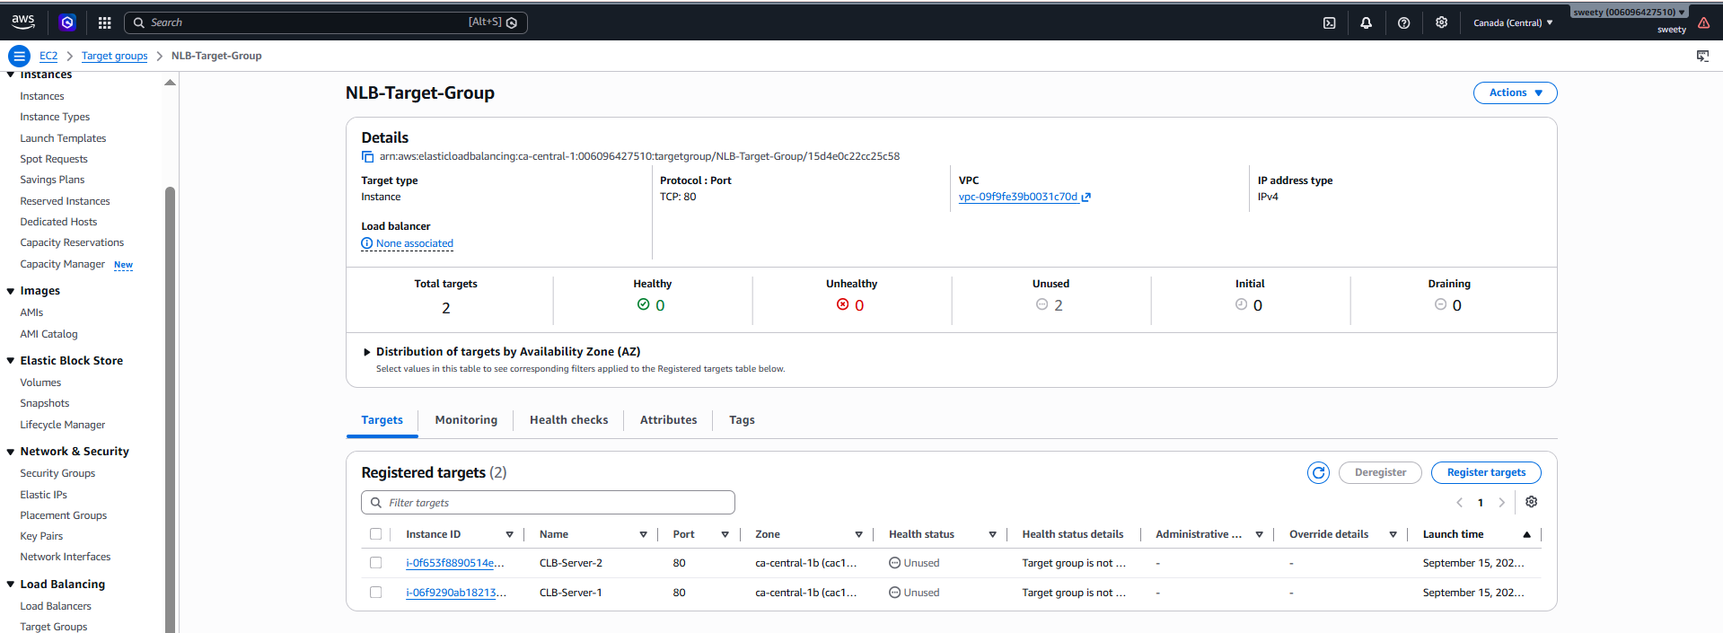

Evidence 2 – Registered Targets
Take a screenshot showing the two registered EC2 instances:
- CLB-Server-1
- CLB-Server-2
Both registered on port 80.
Caption:
Figure 2: EC2 Instances Registered with NLB Target Group

Evidence 3 – NLB Creation Error
Take a screenshot of the AWS server-side task status showing:
Create load balancer: My-Network-Load-Balancer — Error
and:
OperationNotPermittedException: This AWS account currently does not support creating load balancers. For more information, please contact AWS Support.
Caption:
Figure 3: AWS Account Restriction Preventing NLB Creation

4. AWS Error / Status
During the NLB creation process, AWS returned the following error:
OperationNotPermittedException
This AWS account currently does not support creating load balancers. For more information, please contact AWS Support.
The server-side task status was:
Server-side Task | Status
Create load balancer: My-Network-Load-Balancer | Error
Create listeners | Not started
This indicates that the NLB creation was blocked by an AWS account-level restriction. The error was not caused by an incorrect target group configuration.
The NLB-Target-Group was successfully configured, but the Network Load Balancer itself could not be created because the AWS account currently does not support creating additional load balancers.
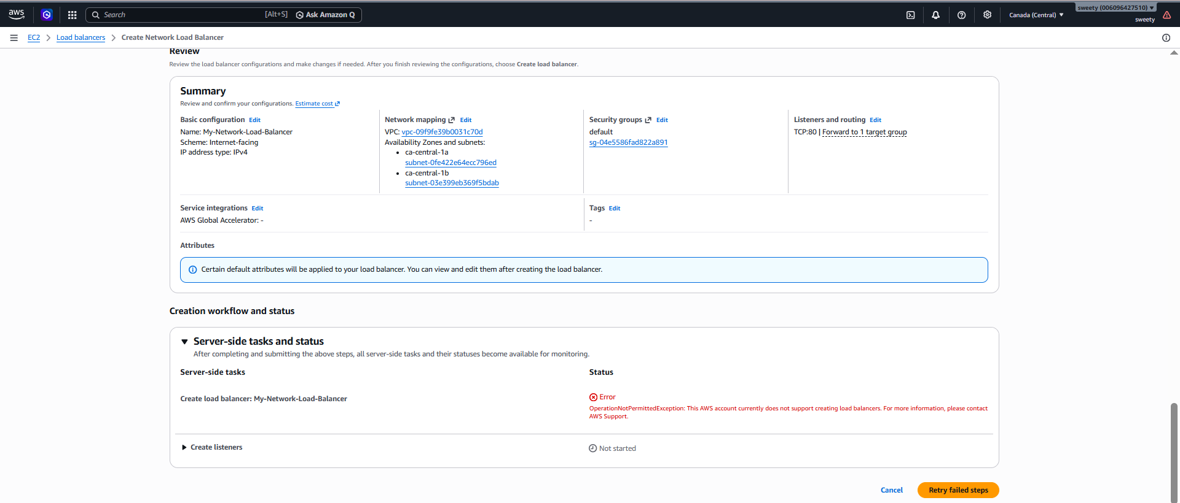

5. Conclusion
The NLB target group was successfully configured using TCP port 80, with two EC2 instances registered as targets and HTTP health checks configured.
However, the Network Load Balancer could not be created because AWS returned an OperationNotPermittedException indicating that the current AWS account does not support creating load balancers. Therefore, the listener configuration and final NLB connectivity test could not be completed.
Task 3 is considered partially completed and blocked by an AWS account-level restriction. The AWS error was documented as evidence for the unsuccessful NLB creation.

NOTE: added the reference pictures from others account.
These are the pictures that are referred from others account
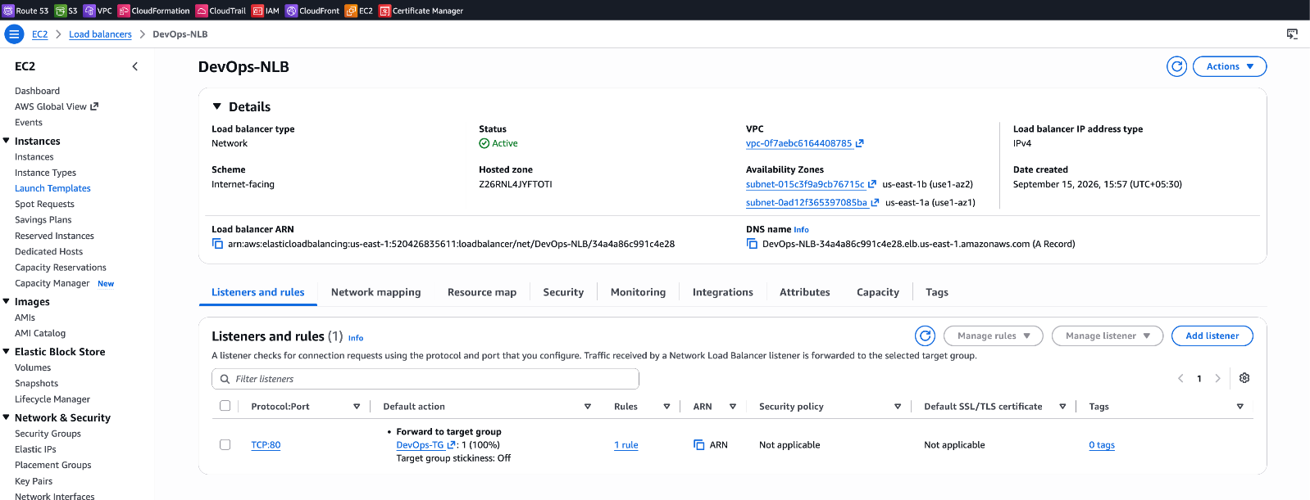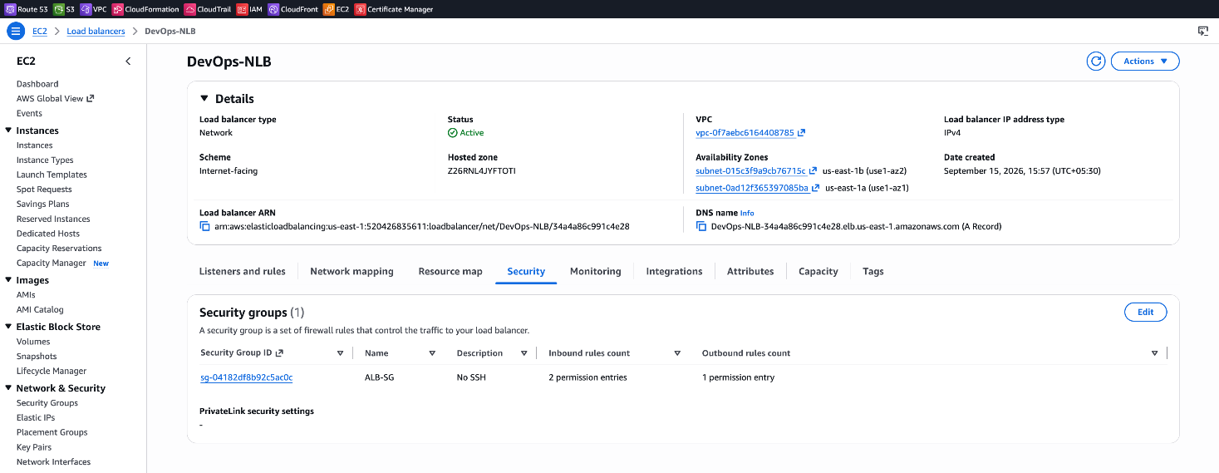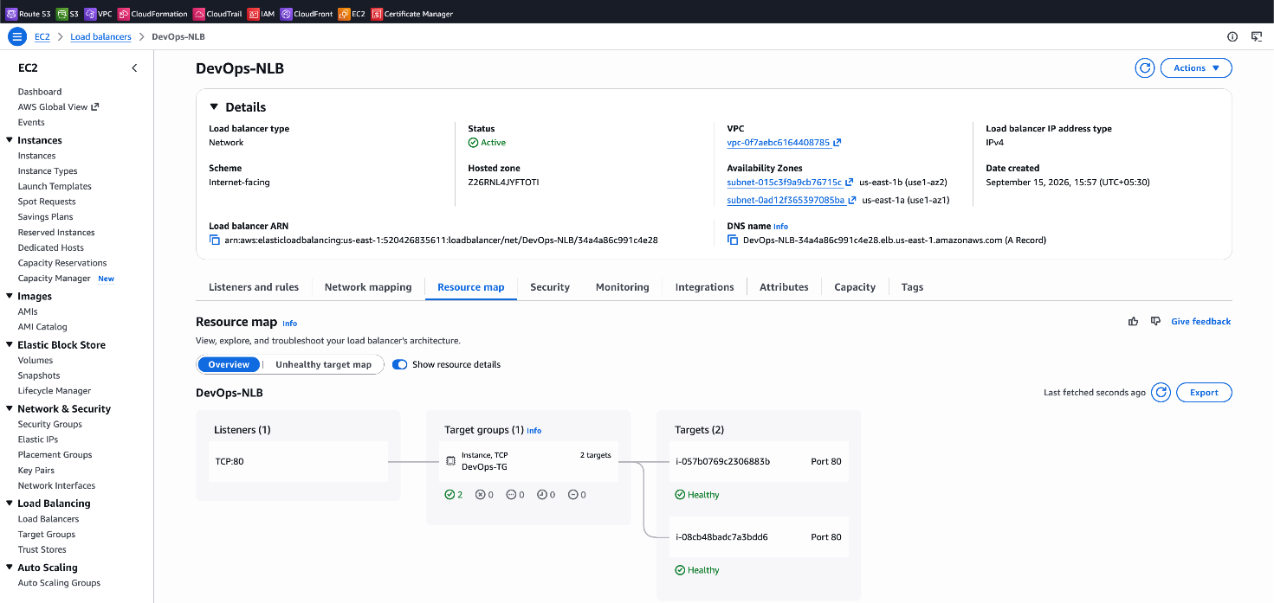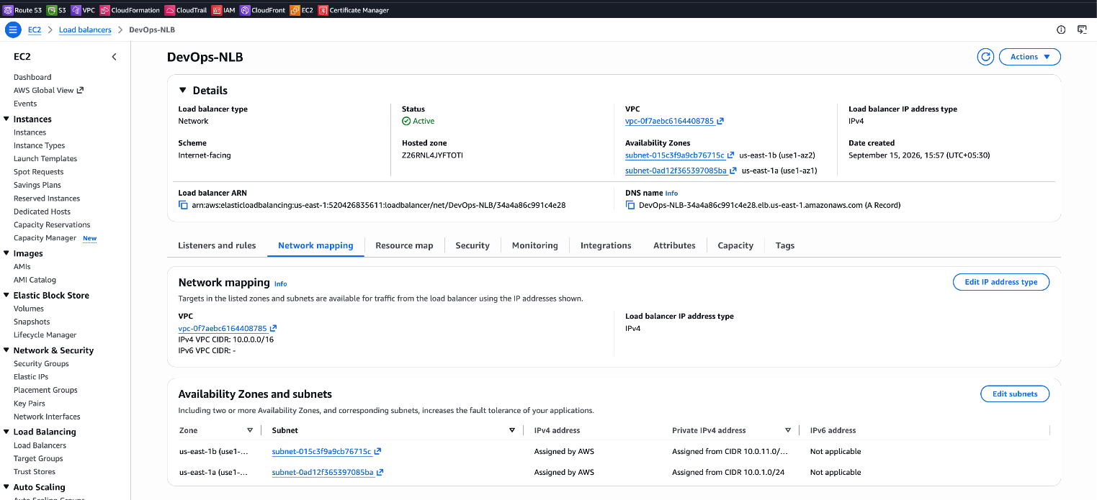

- Attach SSL for application load balancer.
Objective
To secure the Application Load Balancer using an SSL/TLS certificate and enable HTTPS communication on port 443.
Steps
- Open AWS Certificate Manager (ACM) in ca-central-1.
- Request a Public Certificate for:
  - anisweet.online
  - *.anisweet.online
- Select DNS Validation.
- Add the CNAME validation record provided by ACM to the GoDaddy DNS settings.
- Wait for the certificate status to change to Issued.
- Open EC2 → Load Balancers → My-Application-Load-Balancer.
- Add/configure an HTTPS listener:
  - Protocol: HTTPS
  - Port: 443
  - Certificate: anisweet.online
  - Forward to: ALB-Target-Group
- Update the ALB security group to allow:
  - HTTP – Port 80
  - HTTPS – Port 443
- Verify that both EC2 instances in ALB-Target-Group are Healthy.
Evidence
- ACM certificate showing Issued.
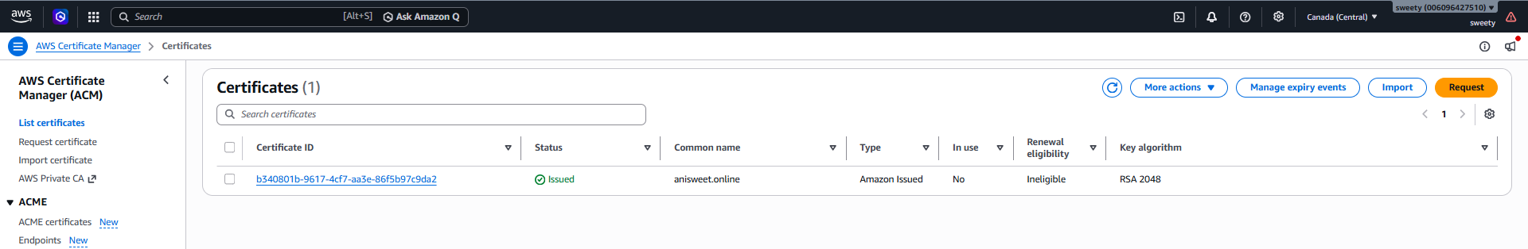

- ALB HTTPS:443 listener showing anisweet.online.
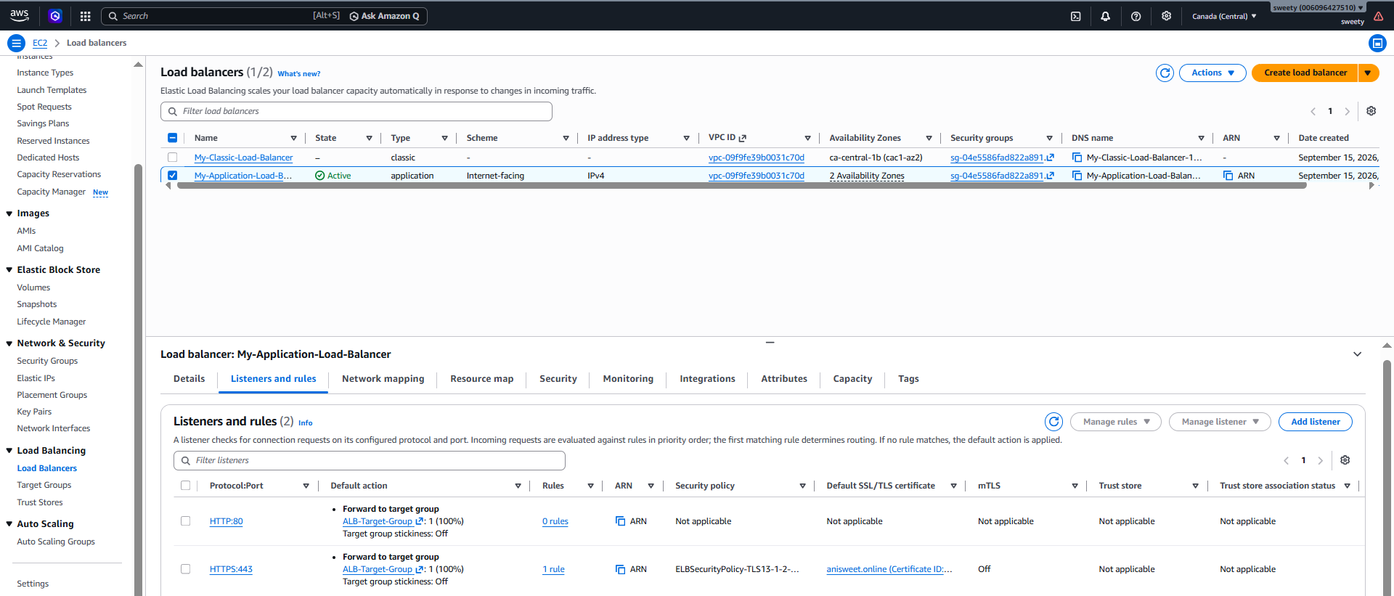
- Security group showing HTTPS 443 allowed.
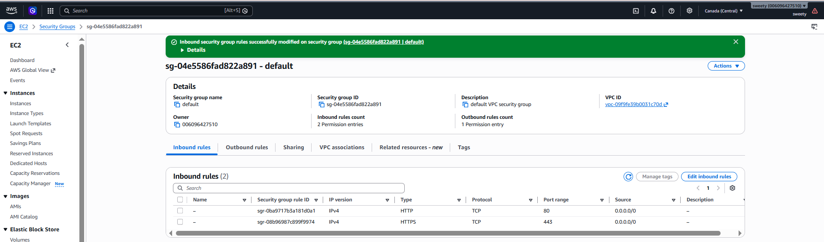
- Target group showing both EC2 instances as Healthy.
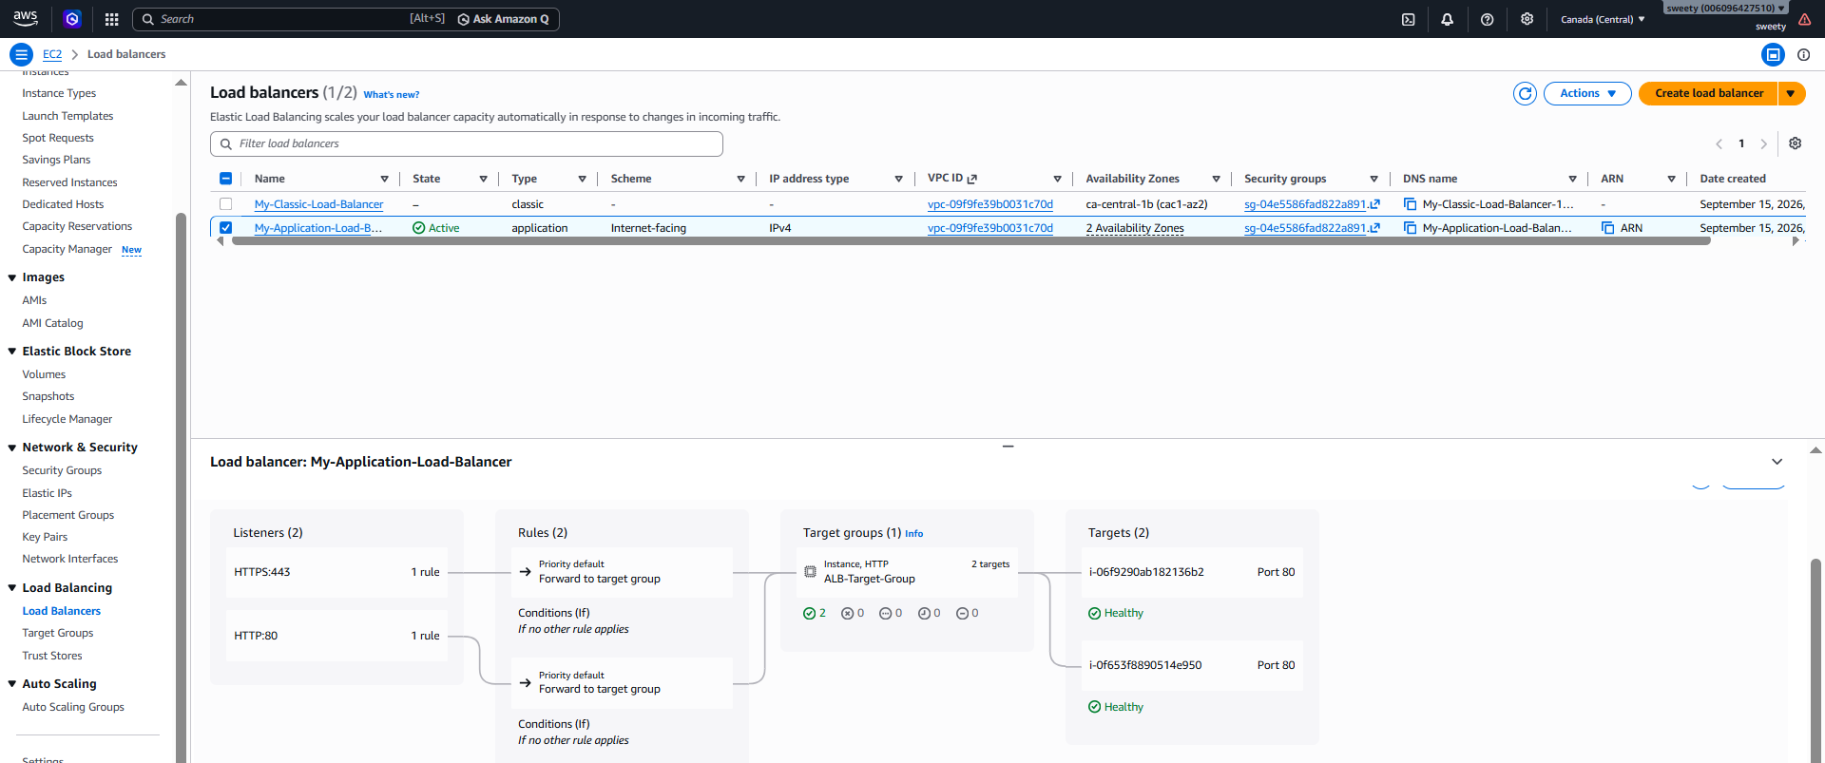
Conclusion
The SSL/TLS certificate was successfully issued through AWS Certificate Manager and attached to the Application Load Balancer's HTTPS listener on port 443. The security group was configured to allow HTTPS traffic, and both backend EC2 instances were healthy. Therefore, SSL/TLS has been successfully configured for the Application Load Balancer.

- Map Application load balancer to R53.
Objective
To map the custom domain anisweet.online to the Application Load Balancer using Amazon Route 53.
Steps
- Open Route 53 from the AWS Console.
- Go to Hosted zones → Create hosted zone.
- Enter:
  - Domain name: anisweet.online
  - Type: Public hosted zone
- Click Create hosted zone.
- Open the hosted zone and click Create record.
- Configure the record:
  - Record name: Leave blank (for the root domain)
  - Record type: A
  - Alias: ON
  - Route traffic to: Alias to Application Load Balancer
  - Region: Canada (Central)
  - Select: My-Application-Load-Balancer
- Click Create records.
Important
Because anisweet.online is currently registered with GoDaddy, you must update the domain's nameservers in GoDaddy to the four Route 53 nameservers shown in the hosted zone.
After DNS propagation, the flow will be:
anisweet.online → Route 53 → Application Load Balancer → ALB Target Group → EC2 Servers
Evidence
- Route 53 hosted zone showing anisweet.online.
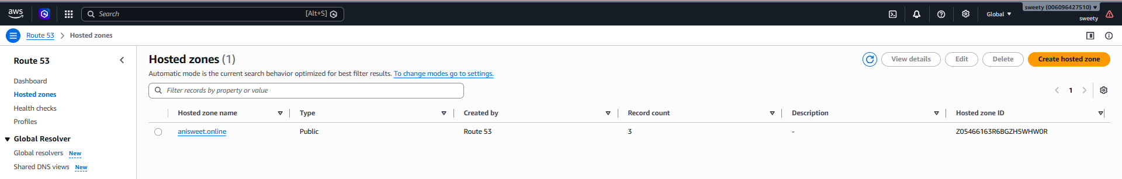

- A record showing Alias → My-Application-Load-Balancer.
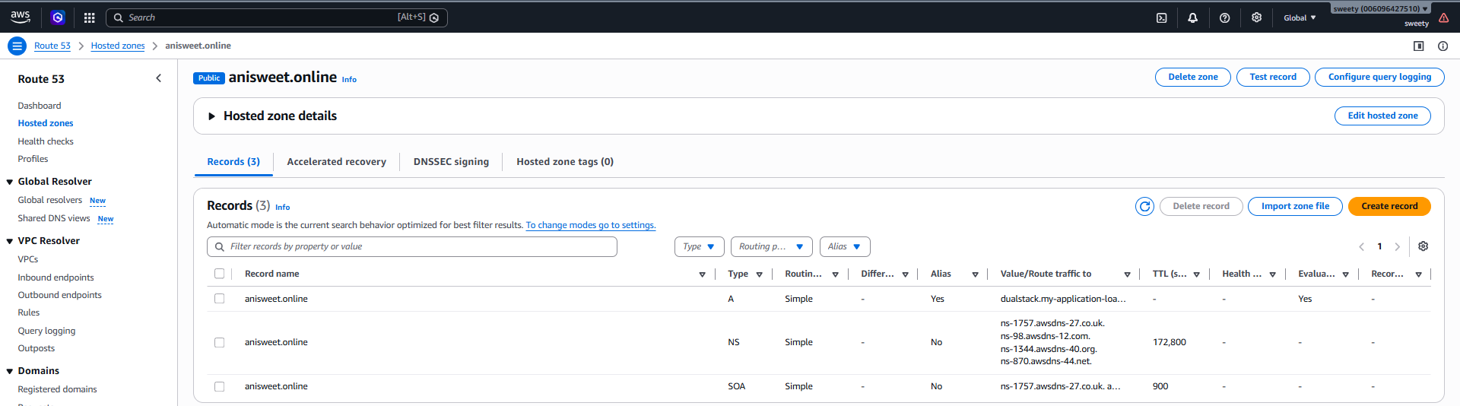
- Route 53 nameservers.
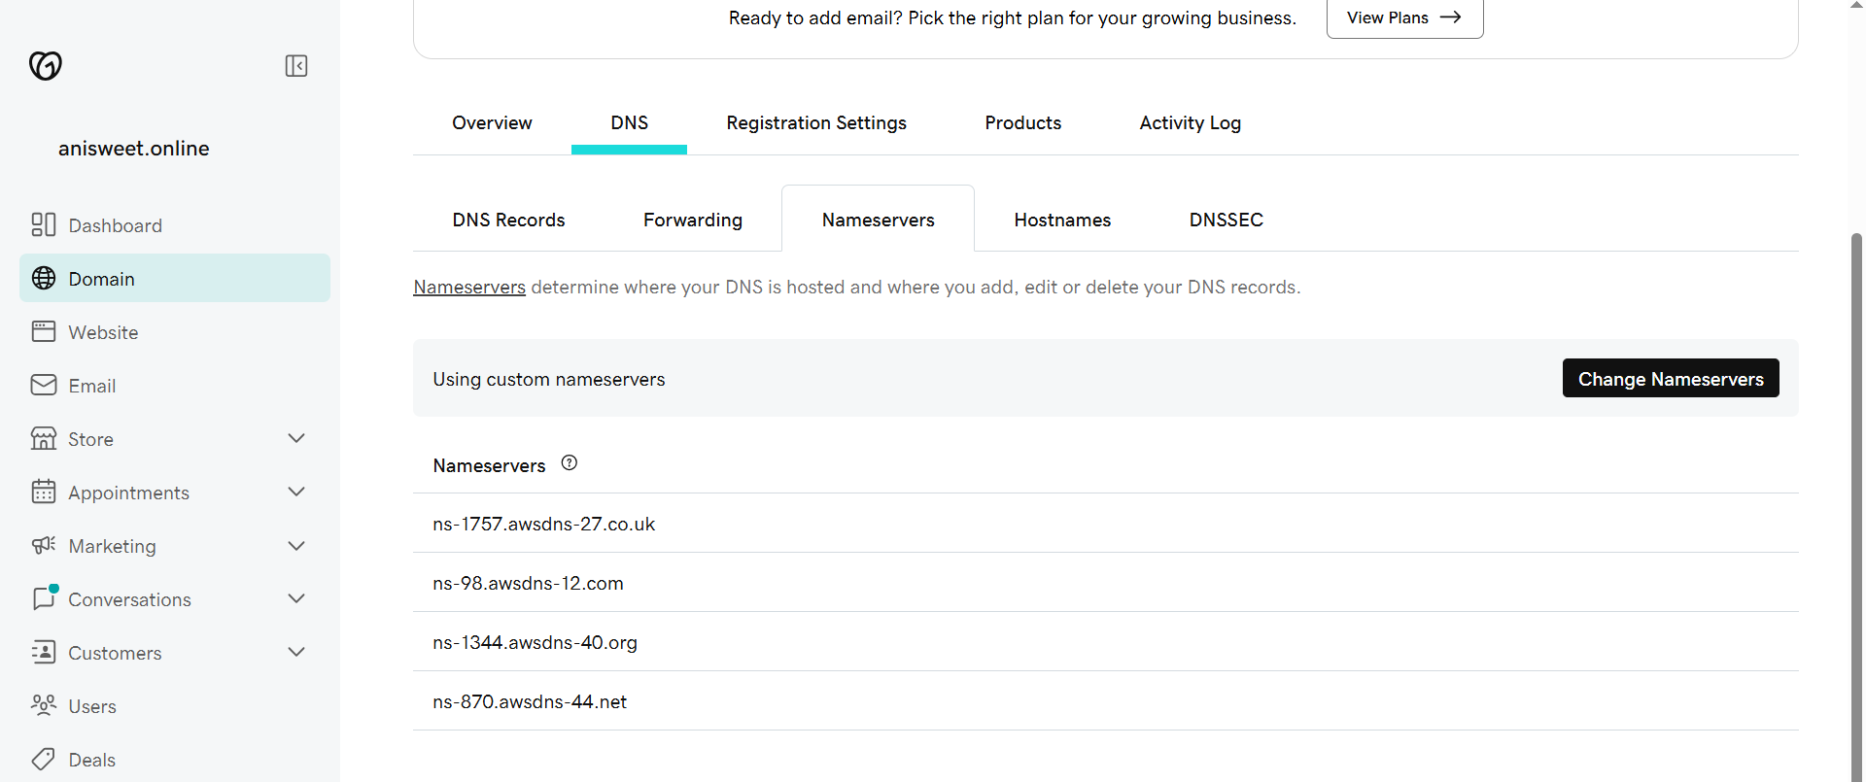
4. Testing the Domain
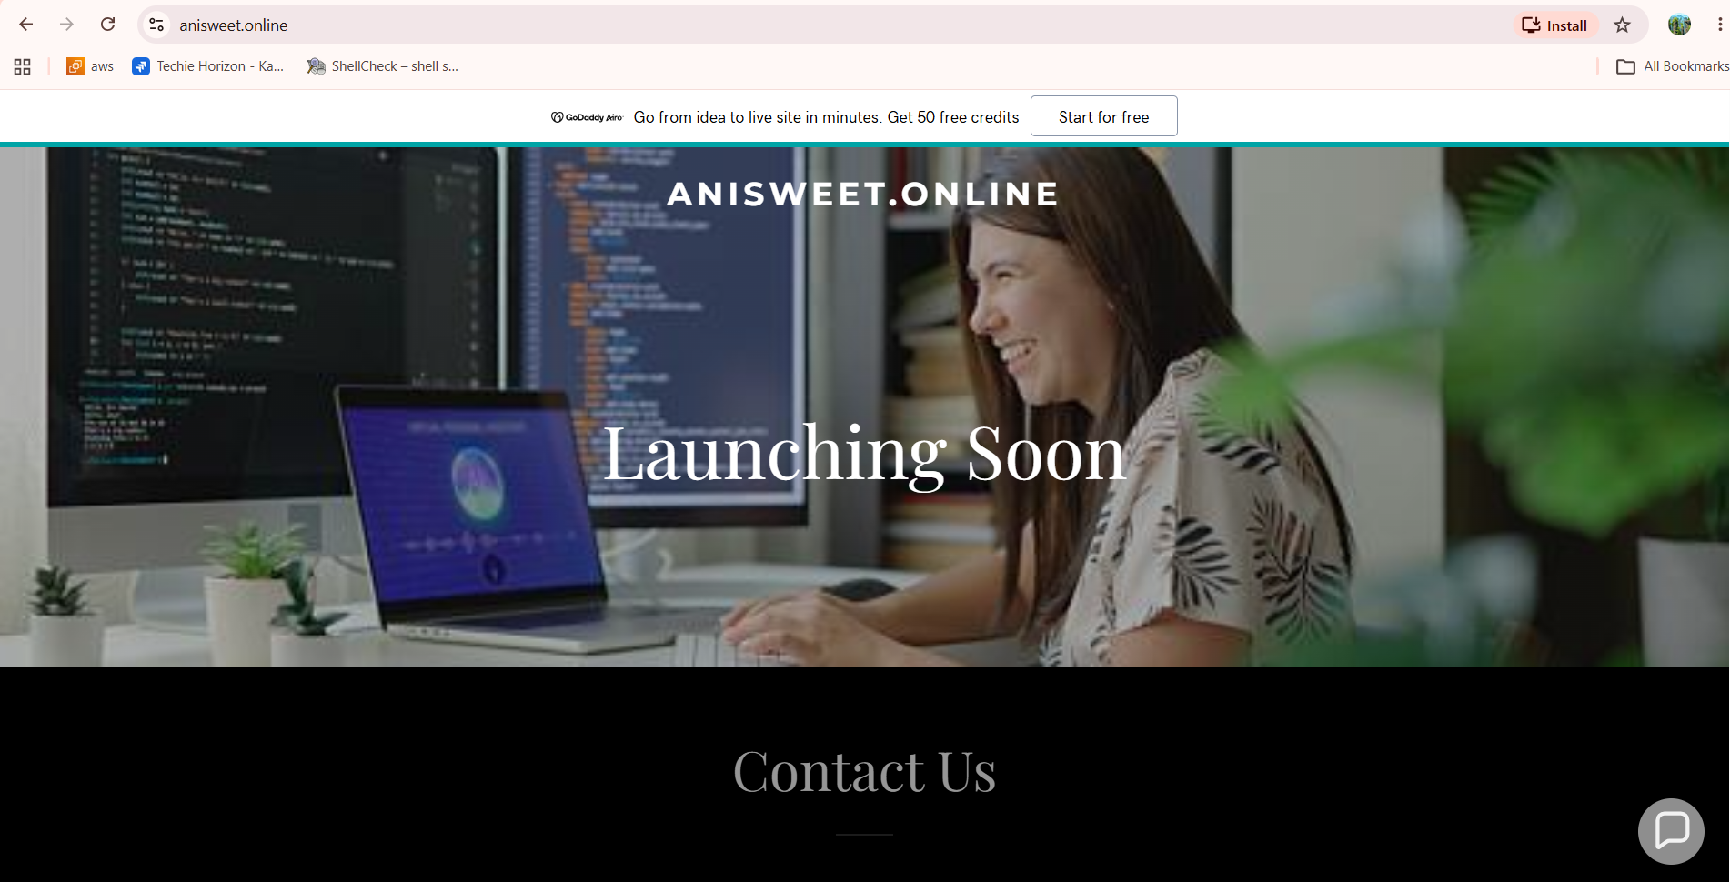
Conclusion
The domain anisweet.online was successfully configured in Amazon Route 53 and mapped to the Application Load Balancer using an Alias A record. This allows users to access the application using the custom domain instead of the ALB DNS name.

- Push the application load balancer logs to S3.
Objective
To enable access logs for the Application Load Balancer and store the logs in an Amazon S3 bucket for monitoring and analysis.
Step 1: Create an S3 Bucket
Go to:
AWS Console → S3 → Create bucket
Use a unique bucket name, for example:
anisweet-alb-logs-2026
Keep the bucket in the same region:
Canada (Central) – ca-central-1
Keep the default settings unless your assignment specifies otherwise, then click Create bucket.
Step 2: Enable ALB Access Logs
Go to:
EC2 → Load Balancers → My-Application-Load-Balancer
Then:
Attributes → Edit
Find Access logs and enable:
Capture access logs
For the destination, select:
S3 bucket
Enter/select your bucket:
anisweet-alb-logs-2026
Then click Save changes.
Step 3: Generate Some Traffic
Open your ALB/application in the browser:
http://My-Application-Load-Balancer-1356157134.ca-central-1.elb.amazonaws.com
You can also access your domain if DNS is already propagated:
https://anisweet.online
Refresh the page a few times to generate access-log entries.
Step 4: Verify Logs in S3
Go to:
S3 → anisweet-alb-logs-2026
ALB logs may appear inside a path similar to:
AWSLogs/
006096427510/
elasticloadbalancing/
ca-central-1/
The logs may take some time to appear.
Evidence
- S3 bucket showing the bucket created for ALB logs.
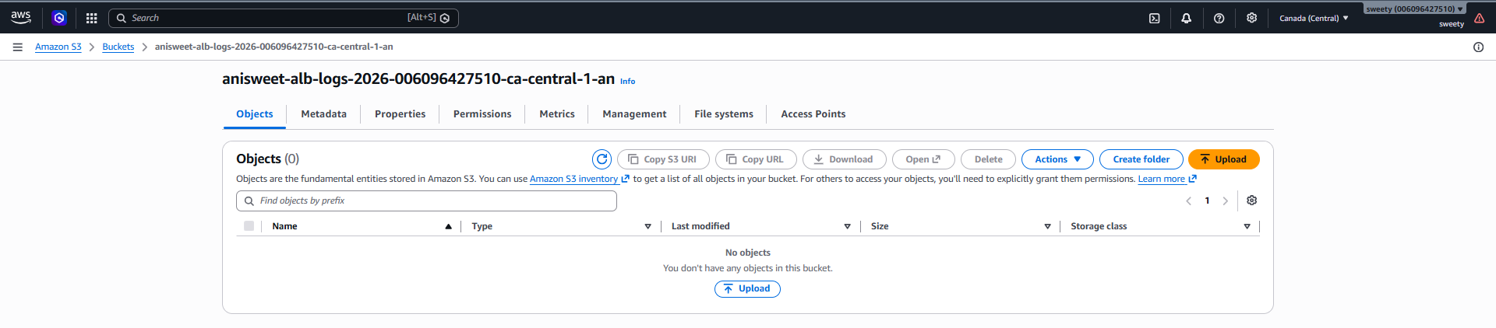
- ALB Attributes → Access logs → Enabled and the S3 destination.
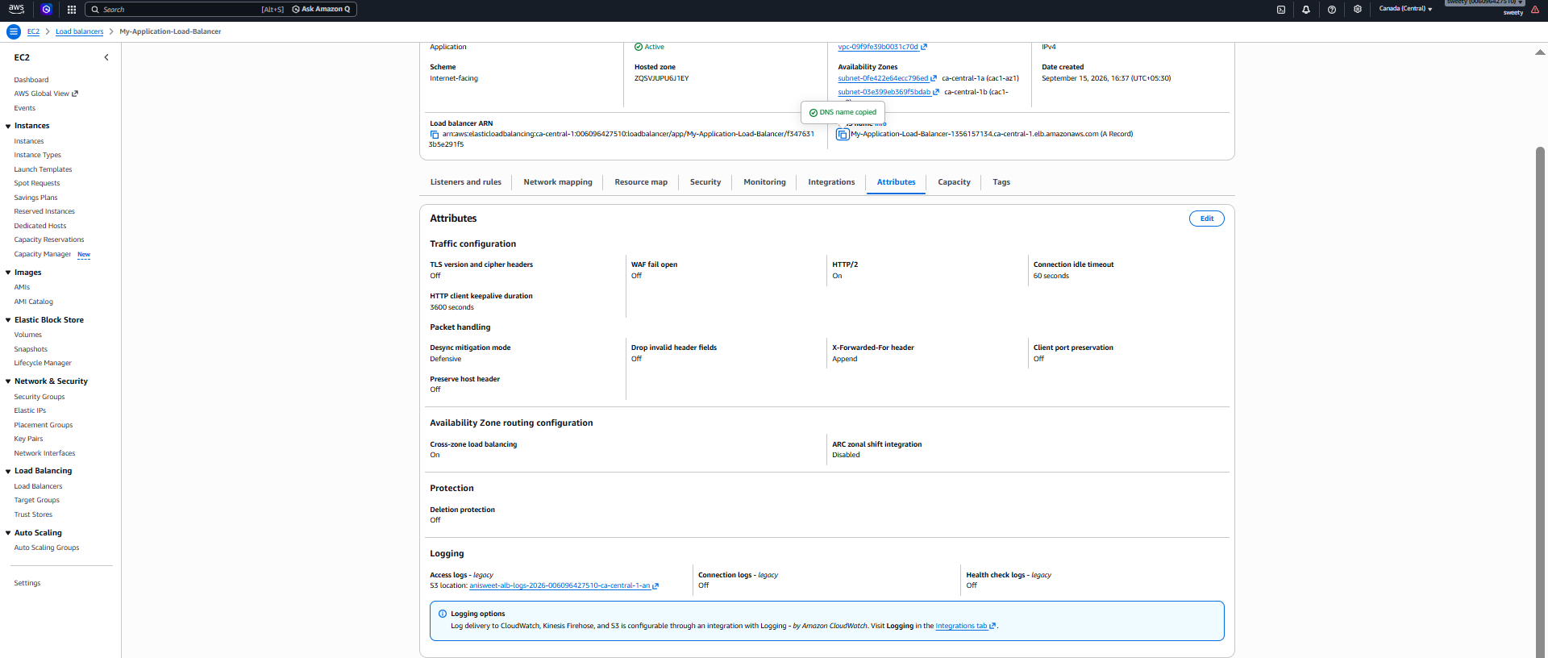
- S3 bucket showing the generated log files.
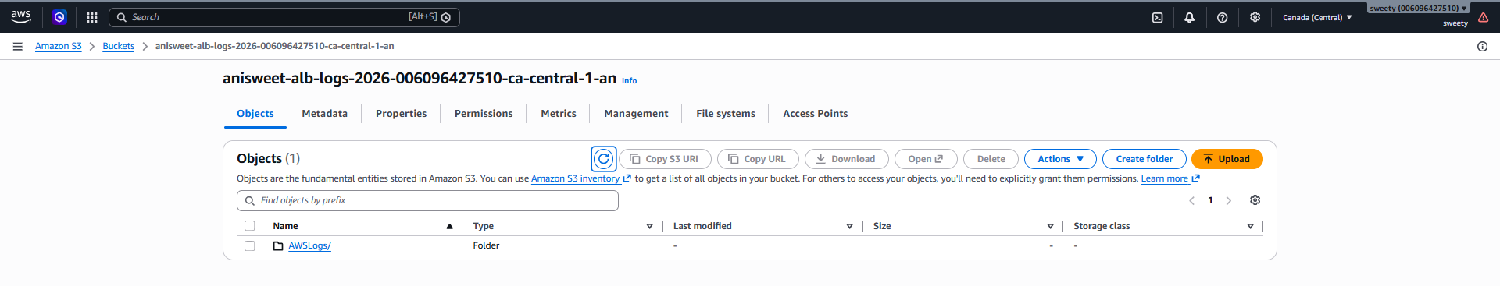
Conclusion
The Application Load Balancer access logs were successfully enabled and configured to be delivered to an Amazon S3 bucket. This allows ALB request activity to be stored for monitoring, troubleshooting, and future analysis.

